VPD-338ZH
Color Vandal Proof Dome Camera
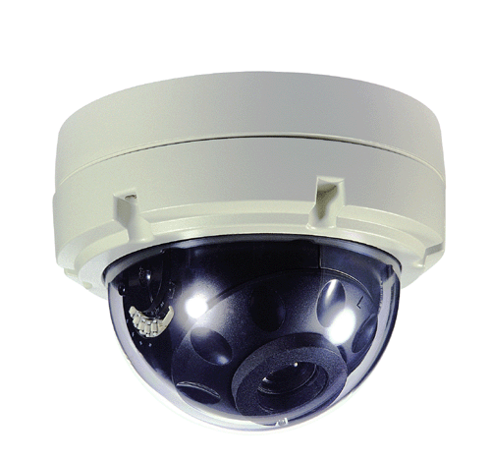
WITH 10X OPTICAL ZOOM LENS
- 1/4” Sony Super HAD CCD
- 10x Optical & 8x Digital Zoom (3.8~38mm/F1.8~2.8)
- Digital Noise Reduction
- Filter Changeable Day & Night Mechanism
- Auto White Balance
- On-Screen-Display Setting
- Aluminum & Poly-Carbonated Housing
- IP66

*Above specification and image subject to change without notice
Image Sensor | 1/4" Sony Super HAD CCD
Effective Pixels | 752H × 582V, 440K Pixels
Scanning System | 535 Lines 2:1 Interlace
Synchronization | Internal/ Line Lock Selectable 0~359 degree (adjustable)
Frequency | 15,734KHz(H), 59.94Hz(V)
Resolution | 500 TV-Lines
Shutter Speed | ESC/ Manual/ FLK (1/50 ~ 1/100,000 sec.)
S/N Ratio | 50dB (AGC Off)
Min. Illumination | Color: 0.7 Lux, B&W: 0.1 Lux
On-Screen-Display | Built-In
Zoom | 10x Optical, 8x Digital
White Balance | ATW/ AWC/ Manual (1,800°K~10,500°K)
Color | On/ Auto
Gain Control | Off/ Low/ Middle/ High
Motion Detection | On/ Off (4 Programming Zone)
Sens-Up | Off/ Auto
Digital Noise Reduction | Off/ Low/ Middle/ High
Mirror | Built-In (Horizontal Image Conversion)
Privacy Function | On/ Off (4 programming Zone)
Video Output | VBS 1.0 Vp-p (75Ω load)
Lens | Vari-Focal DC Auto Iris Lens (3.8mm~38mm/F1.8~2.8)
Backlight Compensation | Off/ Low/ Middle/ High
Power Source | 24V AC (260mA Max.)/12V DC (440mA Max.)
Operating Temp. | -10℃ ~ +50℃
Operating Humidity | 90% RH max.
Dimensions | 6.4(Ø) x 5(H) inch (approx.)
Weight | 2.1 lbs (approx.)

