VPD-271
COLOR VANDAL PROOF DOME CAMERA
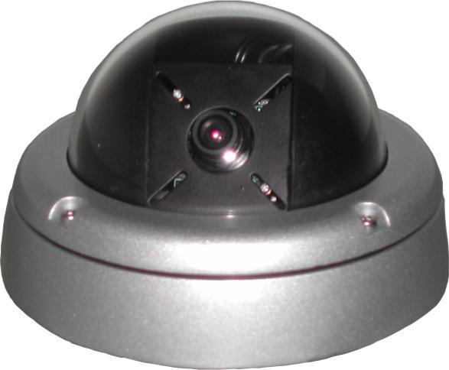
- 1/3” Sony Super HAD CCD
- 420 TV Line
- 3.6mm Lens
- 0.1 Lux
- 12V DC
- Auto Back Light Compensation
- Auto Electronic Iris
- Hi-impact reinforced polycarbonate dome (withstands a 10 lbs sledgehammer blow)

Image Device | 1/3” Sony Super HAD CCD
Effective Pixels | 410,000 pixels, 510(H) x 492(V)
Scanning System | 2:1 Interlaced
Sensitivity | 0.1 Lux (F1.2 lens)
Resolution | 420 TV Line
S/N Ratio | More than 45 dB (AGC off)
Gamma Characteristic | 0.45
Synchronizing Systems | Internal
Shutter Speed | 1/60 ~ 1/10,000 sec.
Gain Control | Automatic
White Balance | Automatic
Video Signal Output | 1.0Vp-p Composite / 75Ω
Power Supply | 12V DC
Power Consumption | 160mA MAX
Lens | 3.6mm, F2.0
Storage Temperature | -21°~+60°C RH95% Max
Operating Temperature | -10°~+50°C RH95% Max
Dimensions | 5.7”∅ × 3.4”(H)

*Above specifications and design subject to change without notice
