SK-2115
COLOR MINI SQUARE CAMERA
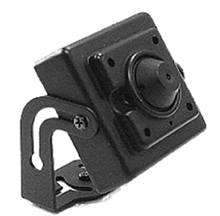
- 1/4” Sony CCD
- Compact Size (1.3” x 1.3”)
- Video, audio, and power cable included
- 3.7mm Lens
- 12V DC
- Audio Output
- Built-In Microphone
Image Sensor | 1/4” Sony Color CCD
Signal System | NTSC
Effective Pixels | 510(H) x 490(V)
H. Resolution | 380 TV line
Min. Illumination | 0.1 Lux (F=1.2)
Synchronizing System | Internal
Video Output | 1.0Vp-p (Sync Negative) Termination 75Ω ±10%, RCA
S/N Ratio | 45dB or more (AGC off)
Gain Control | Automatic
Electronic Shutter | 1/60~100,000 sec
Gamma Correction | r=0.45 typ
Lens | 3.7mm pinhole lens
Power Consumption | DC 12V 150mA
Reverse Polarity Protection | Yes
Operating Temperature | -10°C~50°C, RH 95% Max
Dimensions | 1.3 x 1.3 inch

*Above specifications and design subject to change without notification
