ODH-DUM
SIMULATED OUTDOOR CAMERA
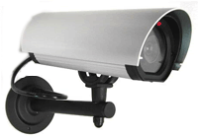
- Authentic styling
- Blinking LEDs
- 2 batteries and mounting bracket included
- Dimensions: 3.6"(W) x 7.2" (H) x 9.2" (D)

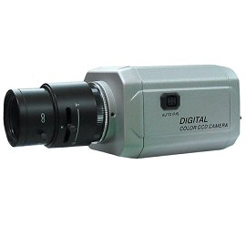

* Above specifications and design subject to change without notice

