LENS-M3-8
3~8MM VARIFOCAL MANUAL IRIS LENS
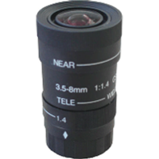
- Variable Focal Length (3 ~ 8mm)
- Manual Iris
- Standard CS Mount

Focal Length |  | 3~8mm
Max. Aperture Ratio |  | 1:1.4
Max. Image Format Size |  | 4.8 x 3.6 (Ø 6) mm
Operation | Iris | F 1.4 ~ close
Operation | Focus | Manual
Operation | Zoom | Manual
Angle of View | Diagonal | 1/3”
Angle of View | Horizontal | 1/3”
Angle of View | Vertical | 1/3”
Optical Distortion |  | 1/3”
Flange Back Focal Length |  | 12.5mm
Back Focal Length |  | 8.70 ~ 14.37mm
Mount |  | CS mount
Operation Temperature |  | -10~50°C
Dimensions (inch) |  | 1.8 x 2.4
Weight |  | 0.2 lbs
*Above specifications and design subject to change without notification

