LENS-A5-80
5~80mm Varifocal Auto Iris Lens
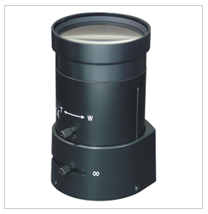
- Variable Focal Length (5~80mm)
- DC Drive Auto Iris
- Standard CS Mount

Focal Length |  | 55~82.5mm
Back Focal Length |  | 9.06~11.72mm
Iris Type |  | Direct Drive
Aperture (F) |  | F1.6~360
Format |  | 1/3”
Angle of View (degree) | Diagonal | 36.5~2.4
Angle of View (degree) | Horizontal | 48.5~3.1
Angle of View (degree) | Vertical | 63.4~3.9
Dimensions (inch) |  | 1.9Ø x 3.3L
Weight |  | 0.4 lbs
Mount |  | CS mount
*Above specifications and design subject to change without notification

