LENS-A5-50
5~50MM VARIFOCAL AUTO IRIS LENS
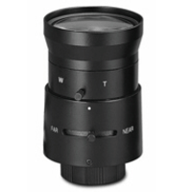
- Variable Focal Length (5~50mm)
- DC Drive Auto Iris
- Standard CS Mount

Focal Length |  | 5~50mm
Max. Aperture Ratio |  | 1:1.4
Operation | Iris | F 1.4 ~ 360
Operation | Focus | Manual
Operation | Zoom | Manual
Angle of View (degree) | Diagonal | 60~7.4
Angle of View (degree) | Horizontal | 49~5.8
Angle of View (degree) | Vertical | 38~4.4
Optical Distortion |  | -1.3~-0.4%
Flange Back Focal Length |  | 12.5mm
Back Focal Length |  | 9.8~11.7mm
Mount |  | CS mount
Operation Temperature |  | -10~50°C
Dimensions (inch) |  | 2 x 2.6
Weight |  | 0.3 lbs
*Above specifications and design subject to change without notification

