LENS-A2.8-12
2.8~12mm Varifocal Auto Iris Lens
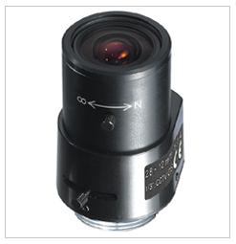
- Variable Focal Length (2.8~12mm)
- DC Drive Auto Iris
- Standard CS Mount

Focal Length |  | 2.8~12mm
Back Focal Length |  | 9.75~20.46
Iris Type |  | Direct Drive
Aperture (F) |  | F1.4~360
Format |  | 1/3”
Angle of View (degree) | Diagonal | 72.5~18.7
Angle of View (degree) | Horizontal | 99.8~25.0
Angle of View (degree) | Vertical | 38~4.4
Dimensions (inch) |  | 1.4Ø x 2.3L
Weight |  | 0.2 lbs
Mount |  | CS mount
*Above specifications and design subject to change without notification

