LENS-08
8MM LENS
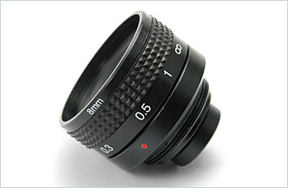
- Focal Length: 8.28 mm
- F-Number: 2.8
- Sensor Size: 1/3” CCD
- Back Focal Length: 7.16 In Air
- Flange Back Length: 17.526 In Air
- Elements: 6 Glass

Focal Length |  | 8.28mm
F-Number |  | 2.8
Sensor Size |  | 1/3” CCD
Operation | Iris | Fixed
Operation | Focus | 20cm ~ ∞
Angle of View | Diagonal | 1/3”, 41°
Angle of View | Horizontal | 1/3”, 33°
Angle of View | Vertical | 1/3”, 24.8°
Entrance Pupil Diameter (mm) |  | 2.96
Entrance Pupil Position (mm) |  | 3.65
Exit Pupil Diameter (mm) |  | 169.19
Exit Pupil Position (mm) |  | 473.82
Back Focal Length (mm) |  | 7.16 In Air
Flange Back Length (mm) |  | 17.526 In Air
Mount Type |  | C mount
Dimensions (inch) |  | 1.4 x 1.2
*Above specifications and design subject to change without notification

