LENS-06
6MM LENS
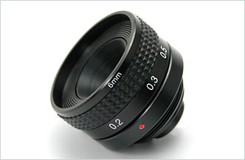
- Focal Length: 6.05mm
- F-Number: 2.0
- Sensor Size: 1/3” CCD
- Back Focal Length: 8.20 In Air
- Flange Back Length: 17.526 In Air
- Elements: 4 Glass

Focal Length |  | 6.05mm
F-Number |  | 2.0
Sensor Size |  | 1/3” CCD
Operation | Iris | Fixed
Operation | Focus | 10cm ~ ∞
Angle of View | Diagonal | 1/3”, 58°
Angle of View | Horizontal | 1/3”, 46°
Angle of View | Vertical | 1/3”, 35°
Entrance Pupil Diameter (mm) |  | 3.02
Entrance Pupil Position (mm) |  | 3.48
Exit Pupil Diameter (mm) |  | 13.21
Exit Pupil Position (mm) |  | -26.31
Back Focal Length (mm) |  | 8.20 In Air
Flange Back Length (mm) |  | 17.526 In Air
Mount Type |  | C mount
Dimensions (inch) |  | 1.4 x 1.2
*Above specifications and design subject to change without notification

