IR-042
IR ILLUMINATOR
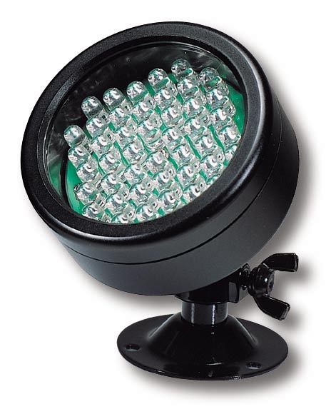
- 42 power Infrared LED lamps (850NM)
- IR range: 35 feet
- Water proof metal case
- Power supply (DC 12V 300mA) included
- Dimensions: Ø 2.6” x D 1.1”

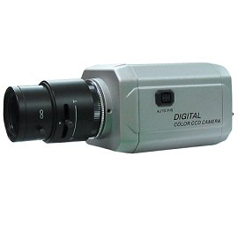

* Above specifications and design subject to change without notice

