HC-SMOKE
SMOKE DETECTOR HIDDEN CAMERA
- 1/3” Sony CCD
- 700 TV Line
- 0.5 Lux
- 3.6mm Board Lens
- 12V DC
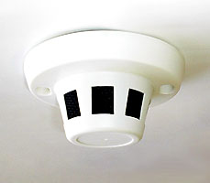
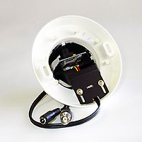
Imaging Sensor: 1/3 inch Sony CCD
Horizontal resolution: 700TVL
Effective Pixels: 976(H)×494(V)
Signal System: NTSC
Clock Frequency: 36 Mhz
Minimum Illumination: 0.1 Lux
Scanning System: 2:1 interlace
Lens: 3.6mm
S/N Ratio: More than 48dB
Sync System: Internal, negative
Auto Electronic Shutter: 1/60s~1/100,000s
Gamma Characteristic: 0.45
Video Output: 1Vpp, 75 ohm
AGC: Yes
Power Supply: DC12V 120mA
Dimensions: 120 x 60mm
Weight: 115g
Storage Temperature: -30°C ~ + 60°C
Operating Temperature: -10°C ~ + 45°C

*Above specifications and design subject to change without notification

