GL-617HB
OUTDOOR CAMERA HOUSING WITH HEATER & BLOWER (SIDE-OPEN TYPE)
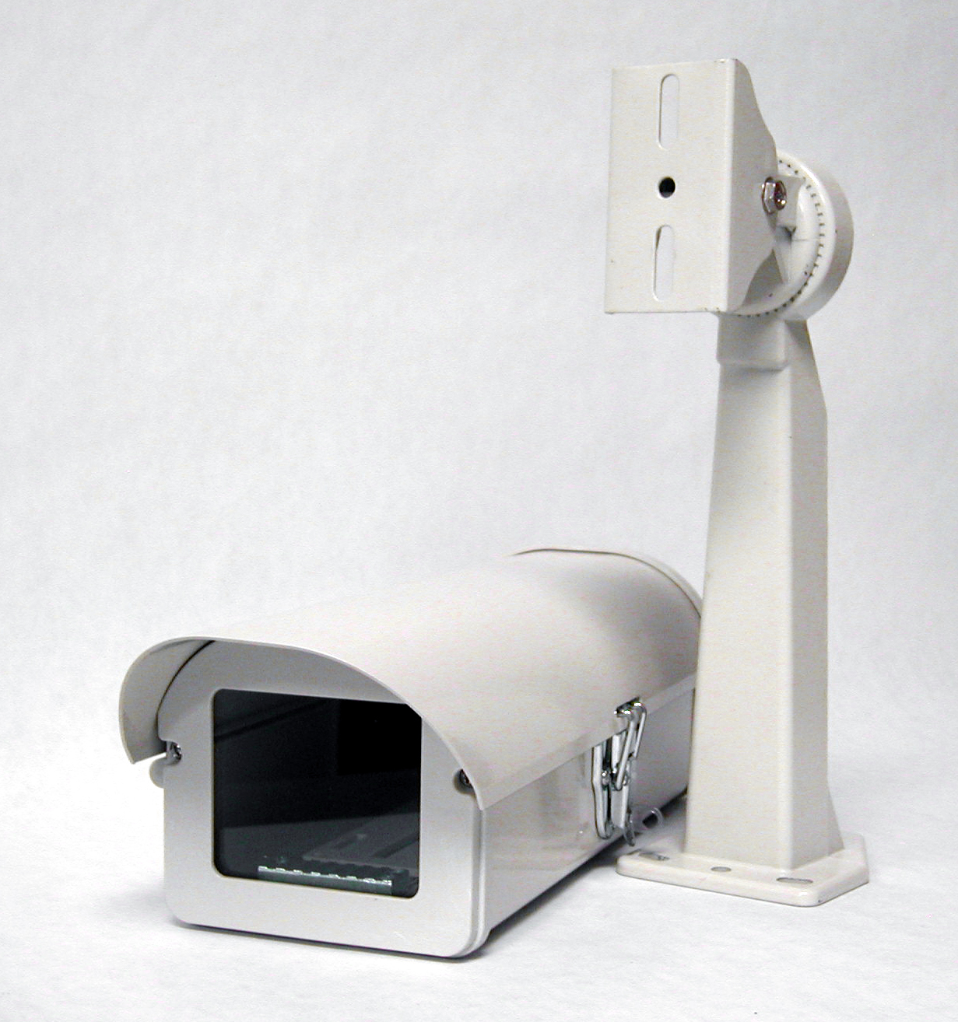

Material | Aluminum
Color | Beige
Dimension | 5.8"(W) x 4.4"(H) x 13.4"(D)
Input Voltage | 24V AC

*Above specifications and design subject to change without notification

