GL-605HB
OUTDOOR CAMERA HOUSING
WITH HEATER & BLOWER
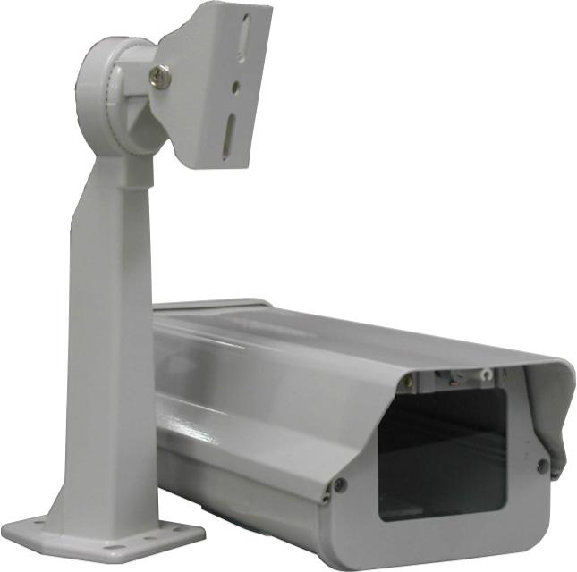
Material |  | Aluminum
Type |  | Open-back
Color |  | Beige
Dimension |  | 5.6"(W) x 4.5"(H) x 15.4"(D) /
Control Temperature | Heater | On: 15°C
Control Temperature | Heater | Off: 25°C
Control Temperature | Blower | On: 35°
Control Temperature | Blower | Off: 25°
Input Voltage |  | 24V AC
*Above specifications and design subject to change without notification

