GL-215
CAMERA HOUSING
CEILING MOUNT BRACKET
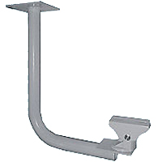
Maximum Load | 10kg (22lbs)
Material | Metal
Color | Beige
Dimensions | 14 Vertical x 7.2 Horizontal inch
Swivel Angle | 360 degree
Tilt Angle | 90 degree
*Above specifications and design subject to change without notification

