DSC-20ECP

Ceiling Pendant Mounting Bracket for PTZ Dome Camera
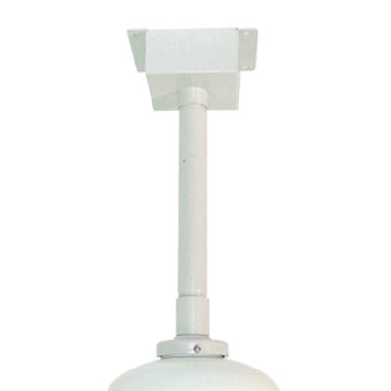
Color | Ivory
Material | Aluminum/Plastic/Poly-Carbonate
Protection | Rust Proof
Weight | 8.4 LBS
Dimensions | 6.1W x 14.1L”
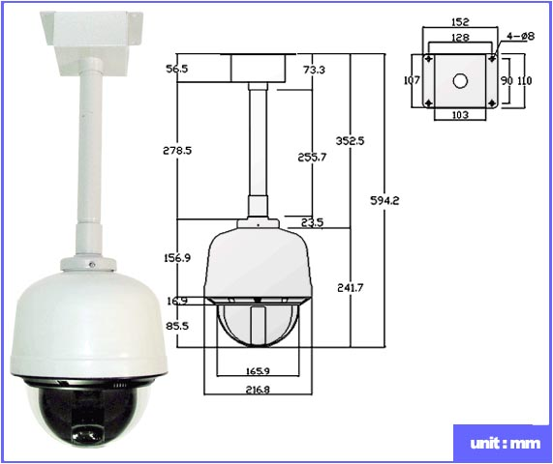

*Above specification and design subject to change without notification

