DOM-DUM
SIMULATED DOME CAMERA
- Authentic styling
- Identical appearance to VCD-271 and VCD-411, color dome cameras
- Dimensions: 4.3”∅ × 2.7”(H)

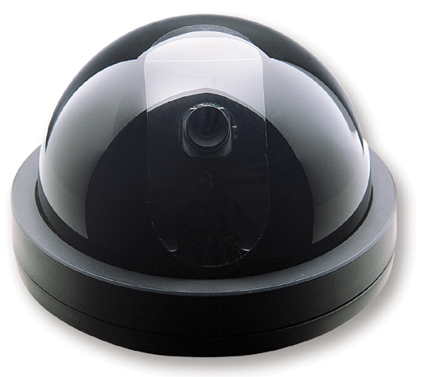
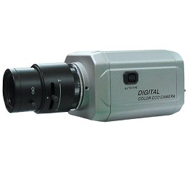

* above specifications and design subject to change without notice

