DOM-4BQ
B&W QUAD DOME CAMERA
- 1/3” CCD
- 4 Cameras built in facing 4 directions
- Remote controller & 60ft cable included
- 12V DC
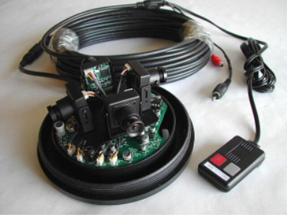
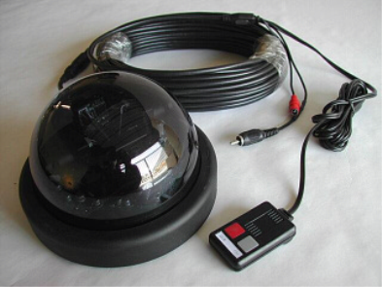

Image Sensor | 1/3” Interline B/W CCD
Resolution | Quad: 320 × 240 (EIA), Camera: 380 TV lines
Video Output | Composite 1.0Vp-p 75Ω, BNC
Minimum Illumination | 0.1 Lux at F 2.0
Scanning System | 2:1 Interlace
Sync. System | Internal
S/N Ratio | More than 48 Db
Shutter Speed | 1/60 ~ 1/100,000 sec. (EIA)
Lens | 3.6 mm (4 cameras, 360°)
Operating Temperature | -10° ~ +50°C
Dimension | 5.69”(Diameter) X 3.87”(H)
Power Supply | DC 12V
*Above specification and design subject to change without notification
