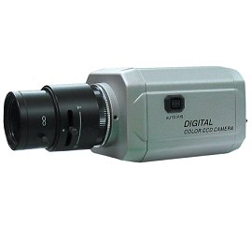
DNC-600H
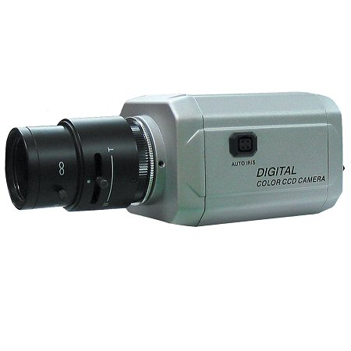
Color High Resolution Day & Night Camera
- Sony 1/3” Super HAD II CCD
- 600 TV Line
- 0.01 Lux
- On Screen Display
- Dead Pixel Compensation
*Above specifications and design subject to change without notification
Total Pixels | 811H x 503V (NTSC), 795H x 596V (PAL)
Effective Pixels | 768H x 494V (NTSC), 752H x 582V (PAL)
Sensor | 1/3” Sony Super HAD II CCD
Scanning System | 2:1 Interlace
Frequency | 15.734KHz x 59.94Hz (NTSC), 15.625KHz x 50.00KHz (PAL)
Resolution | More than 600 TV Lines
S/N Ratio | 52dB or more (AGC Off)
Min. Illumination | 0.01 Lux
Gain Control | Off / Low / Middle / High
White Balance | ATW1(2300°K~9500°K) / ATW2(2000°K~11000°K) / Manual
Electronic Shutter Speed | NTSC: 1/60sec ~1/100,000sec, PAL: 1/50sec ~1/100,000sec
BLC | Off, BLC, HLC Selectable
2D-DNR | On/Off Selectable
Day & Night Selection | Auto/Color/B&W/EXT
D-WDR | On/Off Selectable (Level Adjustable 0~35)
Dead Pixel (DPC) | Off/Auto (Max 74 Points)
IR Smart | On/Off Selectable (IR Gain Level Adjustable 0~255)
Motion Detection | Off/On (4 Areas Selectable)
Privacy Masking | Off/On (8 Masks Selectable)
Lens Shading (LSC) | On/Off Selectable (Level Adjustable 0~255)
Sharpness | On/Off (Level Adjustable 0~30)
OSD | Available
Lens Mount | C/CS Mount
Operating Temperature | -10 Deg~ +50°C / 0~80% RH
Power Supply | DC 12V / AC 24V 130mA
Dimensions | 2.6W x 2.2H x 3.5L Inch
Weight | 0.7 LBS
*Lens not included

