SH-LWP

Large Camera Housing with Water Pump
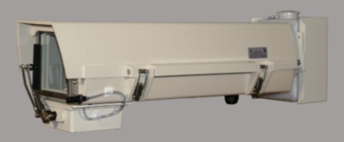

Color | Beige
Material | FRP Injection Molding/Stainless Steel
Input Power | AC 110V, 60Hz
Protection | Dust Proof, IP66, Auto Fan, Heater, Wiper, Water pump
External Dimensions | 28L x 6.4H x 9.9W Inch
Internal Dimensions | 20L x 5.4H x 6.2W Inch
Weight | 11.4 lbs (approx)

*Above specification and design subject to change without notification

