SH-LW

Over-Sized Camera Housing
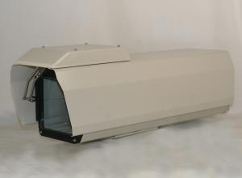

Color | Beige
Material | Aluminum Die-casting / Aluminum Plate
Temperature Control | Fan | On: 35°C
Temperature Control | Fan | Off: 25°C
Temperature Control | Heater | On: 5°C
Temperature Control | Heater | Off: 15°C
Input Power | AC 110V, 60Hz
Protection | Dust Proof, IP66
Wiper | Yes
Defrost | Yes
External Dimensions | 8.8W x 6.5H x 24.1L Inch
Internal Dimensions | 4.4W x 4.2H x 16L Inch
Weight | 18.3 LBS

*Above specification and design subject to change without notification

