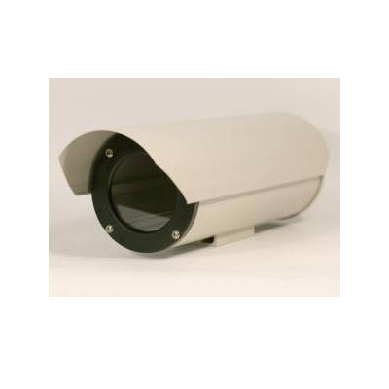
SH-DCA

Die-Casting Aluminum Camera Housing

Color | Beige
Material | Extruding, Die-Casting Aluminum
Protection | Dust Proof, Water Proof, Sunshield
Certification | IP66
Temperature Control | Fan | On: 35°C, Off: 25°C
Temperature Control | Heater | On: 5°C, Off: 15°C
Temperature Control | Double-Walled Jacket
Input Power | AC 110V 60Hz
External Dimensions | 5.5W x 5.4H x 18L Inch
Internal Dimensions | 3.7W x 2.7H x 10.4L Inch
Weight | 4.6 LBS

*Above specification and design subject to change without notification

