DNC-700H
Color High Resolution Day & Night Camera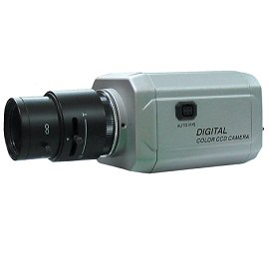
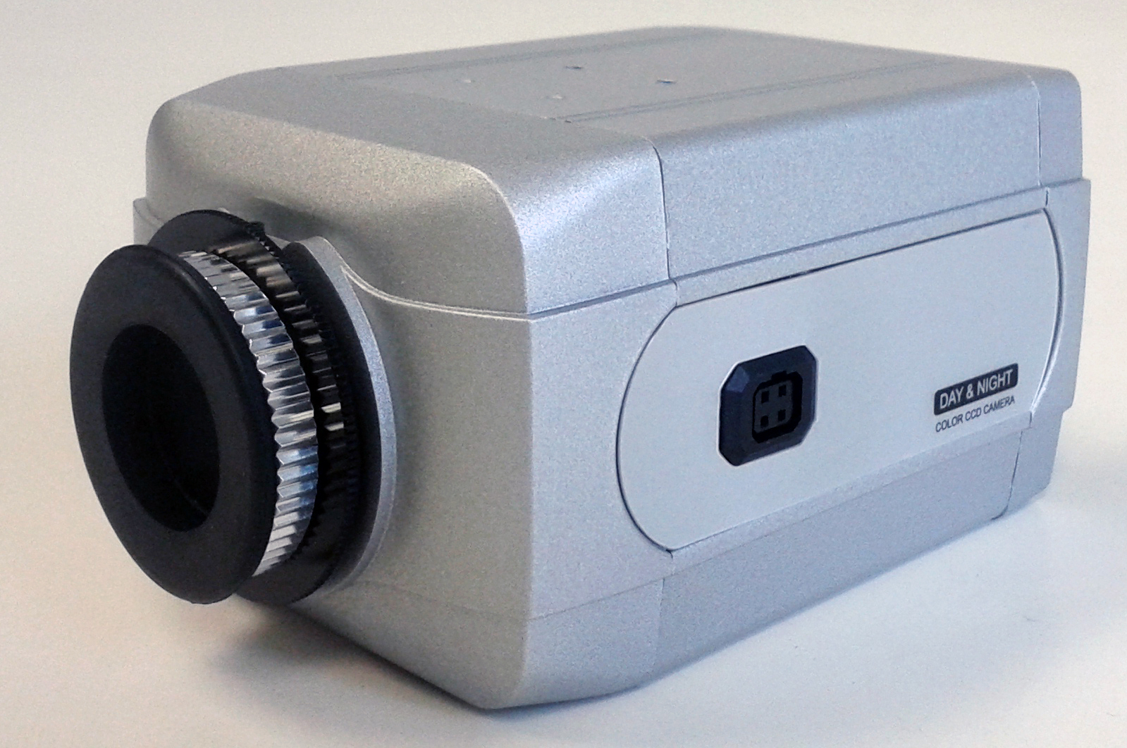
- 700 TV Line
- 0.000002 Lux in Sens-Up Mode
- On Screen Display
- Dead Pixel Compensation

*Above specifications and appearance of product subject to change without notification
Total Pixels | 811H x 508V (NTSC), 795H x 596V (PAL)
Effective Pixels | 768H x 494V (NTSC), 752H x 582V (PAL)
Sensor | 1/3” High Resolution CCD
Scanning System | 2:1 Interlace
Frequency | 15.734KHz x 59.94Hz (NTSC), 15.625KHz x 50.00KHz (PAL)
Resolution | 700 TV Lines
Video Out | 1.0Vp-p composite signal (75 ohm)
S/N (Y Signal | 52dB or more (AGC off)
Min. Illumination | 0.01 Lux
Gain Control | Off / Low / Middle / High
White Balance | ATW1 / ATW2 / AWC / >> Set / Anti. CRL / Manual
Electronic Shutter Speed | NTSC: 1/60sec ~1/100,000sec, PAL: 1/50sec ~1/100,000sec
BLC | Off, BLC, HLC Selectable
2D-DNR | On (0~15) /Off Selectable
Day & Night Selection | Auto/Color/B&W/EXT
D-WDR | Off / low level (0~15) / high level (0~15)
Dead Pixel (DPC) | Selectable
IR Smart | On/Off Selectable (IR Gain Level Adjustable 0~255)
Motion Detection | Off/On (4 Areas Selectable)
Privacy Masking | Off/On (8 Masks Selectable)
Lens Shading (LSC) | On/Off Selectable (Level Adjustable 0~255)
Sharpness | On/Off (Level Adjustable 1~31)
OSD | Available
Lens Mount | C/CS Mount
Operating Temperature | -10 ~ +50°C / 0~80% RH
Power Supply | DC 12V / AC 24V 150mA
Dimensions | 65W x 52H x 108D mm
Weight | Appx. 350g

*Lens not included

