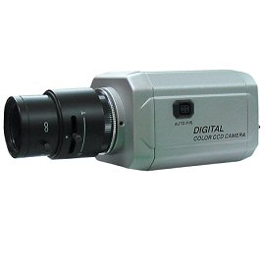
ADC-523
HIGH RESOLUTION COLOR CAMERA
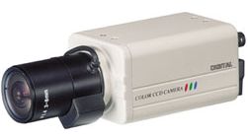
- More than 540 TVL resolution
- Auto tracing white balance
- 0.01 Lux of minimum illumination
- Auto iris function (Video/DC)
- CE, FCC

Specifications:
Image Device: 1/3" SONY Super HAD Color CCD
Picture Elements: 768(H) x 494(V)
Horizontal Resolution: 540 TV Lines
Video Output: 1.0Vp-p 75Ω, negative
Sync System: Internal
Min. Illumination: Color 0.5 lux, B&W 0.01 lux, F1.2
Shutter Speed: 1/60~1/100,000 sec
Signal To Noise Ratio: Better than 50 dB(AGC off)
Gamma Characteristic: 0.45
Back Light Compensation: Yes
White Balance: AWB
Flickerless: On or off
Power Requirements: DC12V+AC24V
Auto Iris: DC
Lens: C/CS mount
Operating Temperature: -10°C~50°C, RH 95% max
Storage Temperature: -20°C~60°C, RH 95% max
Camera Mount: 1/4" - 20 UNC threaded hole
Dimensions: 50(W) x 50(H) x 100(D)mm
Weight: Approx. 233g
Housing: Aluminum

*Above specifications and design subject to change without notification

